**CHAPTER 1**

**INTRODUCTION**

**1.1 Project Overview**

The Blood Donation Agent and Recipient requesting a Blood is to create an e-Information about the donor , recipient and organization that are related to donating the blood and requesting a blood which is required for patient . Through this website any person who is interested in donating the blood can register himself in the same way if any organization wants to register itself with this site that can also register. Moreover if any general consumer wants to make request blood online he can also take the help of this site. Admin is the main authority who can do addition, deletion, and modification if required.

**1.2 Project Description**

This project is aimed to developing an online Blood Donation Information. The entire project has been developed keeping in view of the distributed client server computing technology, in mind.

The Blood Donation Agent is to create an e-Information about the donor and organization that are related to donating the blood. Through this website any person who is interested in donating the blood can register himself in the same way if any organization wants to register itself with this site that can also register. Moreover if any general consumer wants to make request blood online he can also take the help of this site.

Admin is the main authority who can do addition, deletion, and modification if required.

The project has been planned to be having the view of distributed architecture, with centralized storage of the database. The application for the storage of the data has been planned. Using the constructs of MS-SQL Server and all the user interfaces have been designed using the ASP.Net technologies. The database connectivity is planned using the “SQL Connection” methodology. The standards of security and data protective mechanism have been given a big choice for proper usage.

**CHAPTER 2**

**HISTORICAL REVIEW**

* 1. **History of BLOOD**

The ABO blood group **system was discovered in the year 1900 by Karl Landsteiner**. Jan Janský is credited with the first classification of blood into the four types (A, B, AB, and O) in 1907, which remains in use today. In 1907 the first blood transfusion was performed that used the ABO system to predict compatibility.

* 1. **History of Database Management System**

Following the technology progress in the areas of processors, computer memory, computer storage, and computer networks, the sizes, capabilities, and performance of databases and their respective DBMSs have grown in orders of magnitude. The development of database technology can be divided into three eras based on data model or structure: navigational, SQL/relational, and post-relational.[2] The two main early navigational data models were the hierarchical model, epitomized by IBM's IMS system, and the CODASYL model (network model), implemented in a number of products such as IDMS.

The relational model employs sets of ledger-style tables, each used for a different type of entity. Only in the mid-1980s did computing hardware become powerful enough to allow the wide deployment of relational systems (DBMSs plus applications). By the early 1990s, however, relational systems dominated in all large-scale data processing applications, and as of 2015 they remain dominant: IBM DB2, Oracle, MySQL, and Microsoft SQL Server are the top DBMS. The dominant database language, standardized SQL for the relational model, has influenced database languages for other data models.

**2.3 History of MySQL**

MySQL is an open-source relational database management system (RDBMS). MySQL is written in C and C++. Its SQL parser is written in yacc, but it uses a home-brewed lexical analyzer. MySQL works on many system platforms, in**cluding Linux, macOS, Microsoft** Windows, NetBSD. MySQL is offered under two different editions: the open source MySQL Community Server and the proprietary [Enterprise Server](https://en.wikipedia.org/wiki/MySQL_Enterprise). MySQL Enterprise Server is differentiated by a series of proprietary extensions whichinstall as server plugins, but otherwise shares the version numbering system and is built from the same code base.[1]

Major features that are available in MySQL are a broad subset of [ANSI SQL 99](https://en.wikipedia.org/wiki/SQL:1999),as well as extensions, Cross-platform support, [Stored procedures](https://en.wikipedia.org/wiki/Stored_procedure), using a procedural language that closely adheres to [SQL/PSM](https://en.wikipedia.org/wiki/SQL/PSM), [Triggers](https://en.wikipedia.org/wiki/Database_trigger), [Cursors](https://en.wikipedia.org/wiki/Cursor_(databases)), Updatable [views](https://en.wikipedia.org/wiki/View_(SQL)), [Online DDL](https://en.wikipedia.org/wiki/Data_Definition_Language) when using the InnoDB Storage Engine. Many programming languages with language-specific APIs include libraries for accessing MySQL databases. These include MySQL Connector/Net for integration with Microsoft's Visual Studio and the JDBC driver for Java. In addition, an ODBC interface called MySQL Connector/ODBC allows additional programming languages that support the ODBC interface to communicate with a MySQL database, such as ASP or ColdFusion.

**CHAPTER 3**

**REQIREMENT SPECIFICATION**

**3.1 System Requirements**

The basic requirements for the development of this mini project are as follows

**3.1.1 Hardware Configuration**

1. Processor: Intel core i3 or above
2. Ram:512 MB
3. Hard disk:20 GB

**3.1.2 Software Configuration**

1. Front end tool: HTML
2. Back end tool: PHP
3. Development tools: XAMPP server
4. Browser: Google or any
5. Documentation tool: Microsoft office 2003 or above

**3.2 Development Environment**

**3.2.1 Frontend-HTML**

Itis the standard [mark-up language](https://en.wikipedia.org/wiki/Markup_language) for creating [web pages](https://en.wikipedia.org/wiki/Web_page) and web applications.. HTML describes the structure of a web page [semantically](https://en.wikipedia.org/wiki/Semantic_Web) and originally included cues for the appearance of the document.HTML can embed programs written in a [scripting language](https://en.wikipedia.org/wiki/Scripting_language) such as [JavaScript](https://en.wikipedia.org/wiki/JavaScript), which affects the behaviour and content of web pages. Inclusion of CSS defines the look and layout of content. The [World Wide Web Consortium](https://en.wikipedia.org/wiki/World_Wide_Web_Consortium) (W3C), maintainer of both the HTML and the CSS standards, has encouraged the use of CSS over explicit presentational HTML since 1997.

**3.2.2 Backend-MySQL**

Itis an open source relational database management system (RDBMS).

The MySQL development project has made its source code available under the terms of GNU General Public License, as well as under a variety of proprietary agreements. MySQL was owned and sponsored by a single for-profit firm, the Swedish company MySQL AB, now owned by Oracle Corporation. For proprietary use, several paid editions are available, and offered additional functionality. MySQL is central component of LAMP open-source web application software stack. LAMP is an acronym of “Linux, Apache, MySQL, Perl/PHP/Python”. Application that use the MySQL database include TTPO3, MODx, Joomal, WordPress, phpBB, MyBB, and Drupal. MySQL is also used in many high-profile. Large-scale websites, including Google, Facebook, Twitter, Flickr, YouTube.

**3.2.3 PHP**

PHP is a server-side scripting language designed for web development but also used as a general-purpose programming language. PHP is now installed on more than 244 million websites and 2.1 million web servers. Originally created by Rasmus Lerdorf in 1995, the reference implementation of PHP is now produced by The PHP Group. While PHP originally stood for Personal Home Page, it now stands for PHP: Hypertext Preprocessor, a recursive backronym.PHP code is interpreted by a web server with a PHP processor module, which generates the resulting web page: PHP commands can be embedded directly into an HTML source document rather than calling an external file to process data. It has also evolved to include a command-line interface capability and can be used in standalone graphical applications.PHP is free software released under the PHP License. PHP can be deployed on most web servers and also as a standalone shell on almost every operating system and platform, free of charge.

**3.2.4 APACHE**

The Apache HTTP Server is a web server software notable for playing a key role in the initial growth of the World Wide Web. In 2009 it became the first web server software to surpass the 100 million web site milestone. Apache is developed and maintained by an open community of developers under the auspices of the Apache Software Foundation. Since April 1996 Apache has been the most popular HTTP server software in use. As of November 2010 Apache served over 59.36% of all websites and over 66.56% of the first one million busiest websites.

**3.2.5 XAMPP**

XAMPP is a small and light Apache distribution containing the most common web development technologies in a single package. Its contents, small size, and portability make it the ideal tool for students developing and testing applications in PHP and MySQL. XAMPP is available as a free download in two specific packages: full and lite. While the full package download provides a wide array of development tools, XAMPP Lite contains the necessary technologies that meet the Ontario Skills Competition standards.The light version is a small package containing Apache HTTP Server, PHP, MySQL, phpMyAdmin, Openssl, and SQLite.

**Operating System Windows 10**

|  |  |
| --- | --- |
| [[Screenshot of the default MySQL command-line banner and prompt](https://en.wikipedia.org/wiki/File:Mysql-screenshot.PNG)](https://en.wikipedia.org/wiki/File:Mysql-screenshot.PNG)  [Screenshot](https://en.wikipedia.org/wiki/Screenshot) of the default MySQL command-line banner and prompt | |
| [**Original author(s)**](https://en.wikipedia.org/wiki/Software_developer) | [MySQL AB](https://en.wikipedia.org/wiki/MySQL_AB) |
| [**Developer(s)**](https://en.wikipedia.org/wiki/Software_developer) | [Oracle Corporation](https://en.wikipedia.org/wiki/Oracle_Corporation) |
| **Initial release** | 23 May 1995; 22 years ago |
|  | |
| [**Stable release**](https://en.wikipedia.org/wiki/Software_release_life_cycle) | 5.7.20[[1]](https://en.wikipedia.org/wiki/MySQL#cite_note-mysql_release-1) / 16 October 2017; 37 days ago |
| [**Preview release**](https://en.wikipedia.org/wiki/Software_release_life_cycle) | 8.0.3 rc[[2]](https://en.wikipedia.org/wiki/MySQL" \l "cite_note-2) / 21 September 2017; 2 months ago |
| [**Repository**](https://en.wikipedia.org/wiki/Repository_(version_control)) | <https://github.com/mysql/mysql-server>, <git://anongit.gentoo.org/proj/mysql-extras.git> |
| **Development status** | Active |
| **Written in** | [C](https://en.wikipedia.org/wiki/C_(programming_language)), [C++](https://en.wikipedia.org/wiki/C%2B%2B)[[3]](https://en.wikipedia.org/wiki/MySQL#cite_note-3) |
| [**Operating system**](https://en.wikipedia.org/wiki/Operating_system) | [Windows](https://en.wikipedia.org/wiki/Microsoft_Windows), [Linux](https://en.wikipedia.org/wiki/Linux), [Solaris](https://en.wikipedia.org/wiki/Solaris_(operating_system)), [macOS](https://en.wikipedia.org/wiki/MacOS" \o "MacOS), [FreeBSD](https://en.wikipedia.org/wiki/FreeBSD)[[4]](https://en.wikipedia.org/wiki/MySQL#cite_note-4) |
| **Available in** | [English](https://en.wikipedia.org/wiki/English_language) |
| [**Type**](https://en.wikipedia.org/wiki/Software_categories#Broad_categories) | [RDBMS](https://en.wikipedia.org/wiki/Relational_database_management_system) |
| [**License**](https://en.wikipedia.org/wiki/Software_license) | [GPL](https://en.wikipedia.org/wiki/GNU_General_Public_License) (version 2) or [proprietary](https://en.wikipedia.org/wiki/Proprietary_software)[[5]](https://en.wikipedia.org/wiki/MySQL#cite_note-5) |
| **Website** | [www.mysql.com](http://www.mysql.com/) |

**Figure 3.1 MySQL**

**XAMPP**

|  |  |  |
| --- | --- | --- |
| **[Xampp logo.svg](https://en.wikipedia.org/wiki/File:Xampp_logo.svg)** | | |
| [XAMPP In Action on OSX.png](https://en.wikipedia.org/wiki/File:XAMPP_In_Action_on_OSX.png) | | |
| **Figure 3.2(a) A screenshot of XAMPP running all servers on Mac OS** | | |
| [**Developer(s)**](https://en.wikipedia.org/wiki/Software_developer) | Apache Friends | |
| **Initial release** | May 22, 2002; 15 years ago | |
|  | | |
| [**Stable release**](https://en.wikipedia.org/wiki/Software_release_life_cycle) | 7.1.11 - [Windows](https://en.wikipedia.org/wiki/Microsoft_Windows) 7.1.11 - [Linux](https://en.wikipedia.org/wiki/Linux) 7.1.11 - [macOS](https://en.wikipedia.org/wiki/MacOS" \o "MacOS) / November 10, 2017; 7 days ago | |
| [**Repository**](https://en.wikipedia.org/wiki/Repository_(version_control)) | <https://github.com/ApacheFriends> | |
| **Development status** | Active | |
| **Written in** | Various Languages | |
| [**Operating system**](https://en.wikipedia.org/wiki/Operating_system) | [Cross-platform](https://en.wikipedia.org/wiki/Cross-platform) [Linux](https://en.wikipedia.org/wiki/Linux) [Windows](https://en.wikipedia.org/wiki/Microsoft_Windows) [Solaris](https://en.wikipedia.org/wiki/Solaris_(operating_system)) [macOS](https://en.wikipedia.org/wiki/MacOS) | |
| [**Platform**](https://en.wikipedia.org/wiki/Computing_platform) | [Windows](https://en.wikipedia.org/wiki/Microsoft_Windows) - [2008](https://en.wikipedia.org/wiki/Windows_Server_2008), [2012](https://en.wikipedia.org/wiki/Windows_Server_2012), [Vista](https://en.wikipedia.org/wiki/Windows_Vista), [7](https://en.wikipedia.org/wiki/Windows_7), [8](https://en.wikipedia.org/wiki/Windows_8), [10](https://en.wikipedia.org/wiki/Windows_10) x32 Bit [Linux](https://en.wikipedia.org/wiki/Linux) - [Debian](https://en.wikipedia.org/wiki/Debian), [RedHat](https://en.wikipedia.org/wiki/Red_Hat_Linux), [CentOS](https://en.wikipedia.org/wiki/CentOS), [Ubuntu](https://en.wikipedia.org/wiki/Ubuntu_(operating_system)), [Fedora](https://en.wikipedia.org/wiki/Fedora_(operating_system)), [Gentoo](https://en.wikipedia.org/wiki/Gentoo_Linux), [Arch](https://en.wikipedia.org/wiki/Arch_Linux), [SUSE](https://en.wikipedia.org/wiki/SUSE) x32 or x64 Bit [macOS](https://en.wikipedia.org/wiki/MacOS) - [10.6](https://en.wikipedia.org/wiki/Mac_OS_X_Snow_Leopard) or later x64 Bit | |
| [**Size**](https://en.wikipedia.org/wiki/File_size) | [Windows](https://en.wikipedia.org/wiki/Microsoft_Windows) x32 Bit - 120 Mb [Linux](https://en.wikipedia.org/wiki/Linux) x64 Bit - 137 Mb [macOS](https://en.wikipedia.org/wiki/MacOS) x64 Bit - 137 Mb | |
| **Available in** | 11 languages | |
| [[show]](https://en.wikipedia.org/wiki/XAMPP)  **List of languages** | | |
|  | | |
| [**Type**](https://en.wikipedia.org/wiki/Software_categories#Broad_categories) | [WAMP](https://en.wikipedia.org/wiki/WAMP), [MAMP](https://en.wikipedia.org/wiki/MAMP), [SAMP](https://en.wikipedia.org/wiki/SAMP_(Sun_Web_Stack)), [LAMP](https://en.wikipedia.org/wiki/LAMP_(software_bundle)) | |
| [**License**](https://en.wikipedia.org/wiki/Software_license) | [GNU General Public Licence](https://en.wikipedia.org/wiki/GNU_General_Public_License) | |
| [**Alexa**](https://en.wikipedia.org/wiki/Alexa_Internet)**rank** | Decrease10,525[[1]](https://en.wikipedia.org/wiki/XAMPP#cite_note-1) | |
| **Website** | [apachefriends.org](https://www.apachefriends.org/) | |

**Figure 3.2(b)Apache Server**

**3.3 Normalization**

Normalization is a process of organizing the data in database to avoid data redundancy, insertion anomaly, update anomaly & deletion anomaly. To overcome these anomalies we need to normalize the data. There are 4 basic types of normalizations. They are:

* First normal form(1NF)
* Second normal form(2NF)
* Third normal form(3NF)
* Boyce & Codd normal form (BCNF)

A table is said to be in 2NF if the two conditions stated are satisfied. The table is in First normal form and all the non-prime attribute are dependent on the proper subset of any candidate key of table. The attribute that is not part of any candidate key are known as non-prime attribute.

**CHAPTER 4**

**SYSTEM DESIGN**

4.1 E-R Diagram

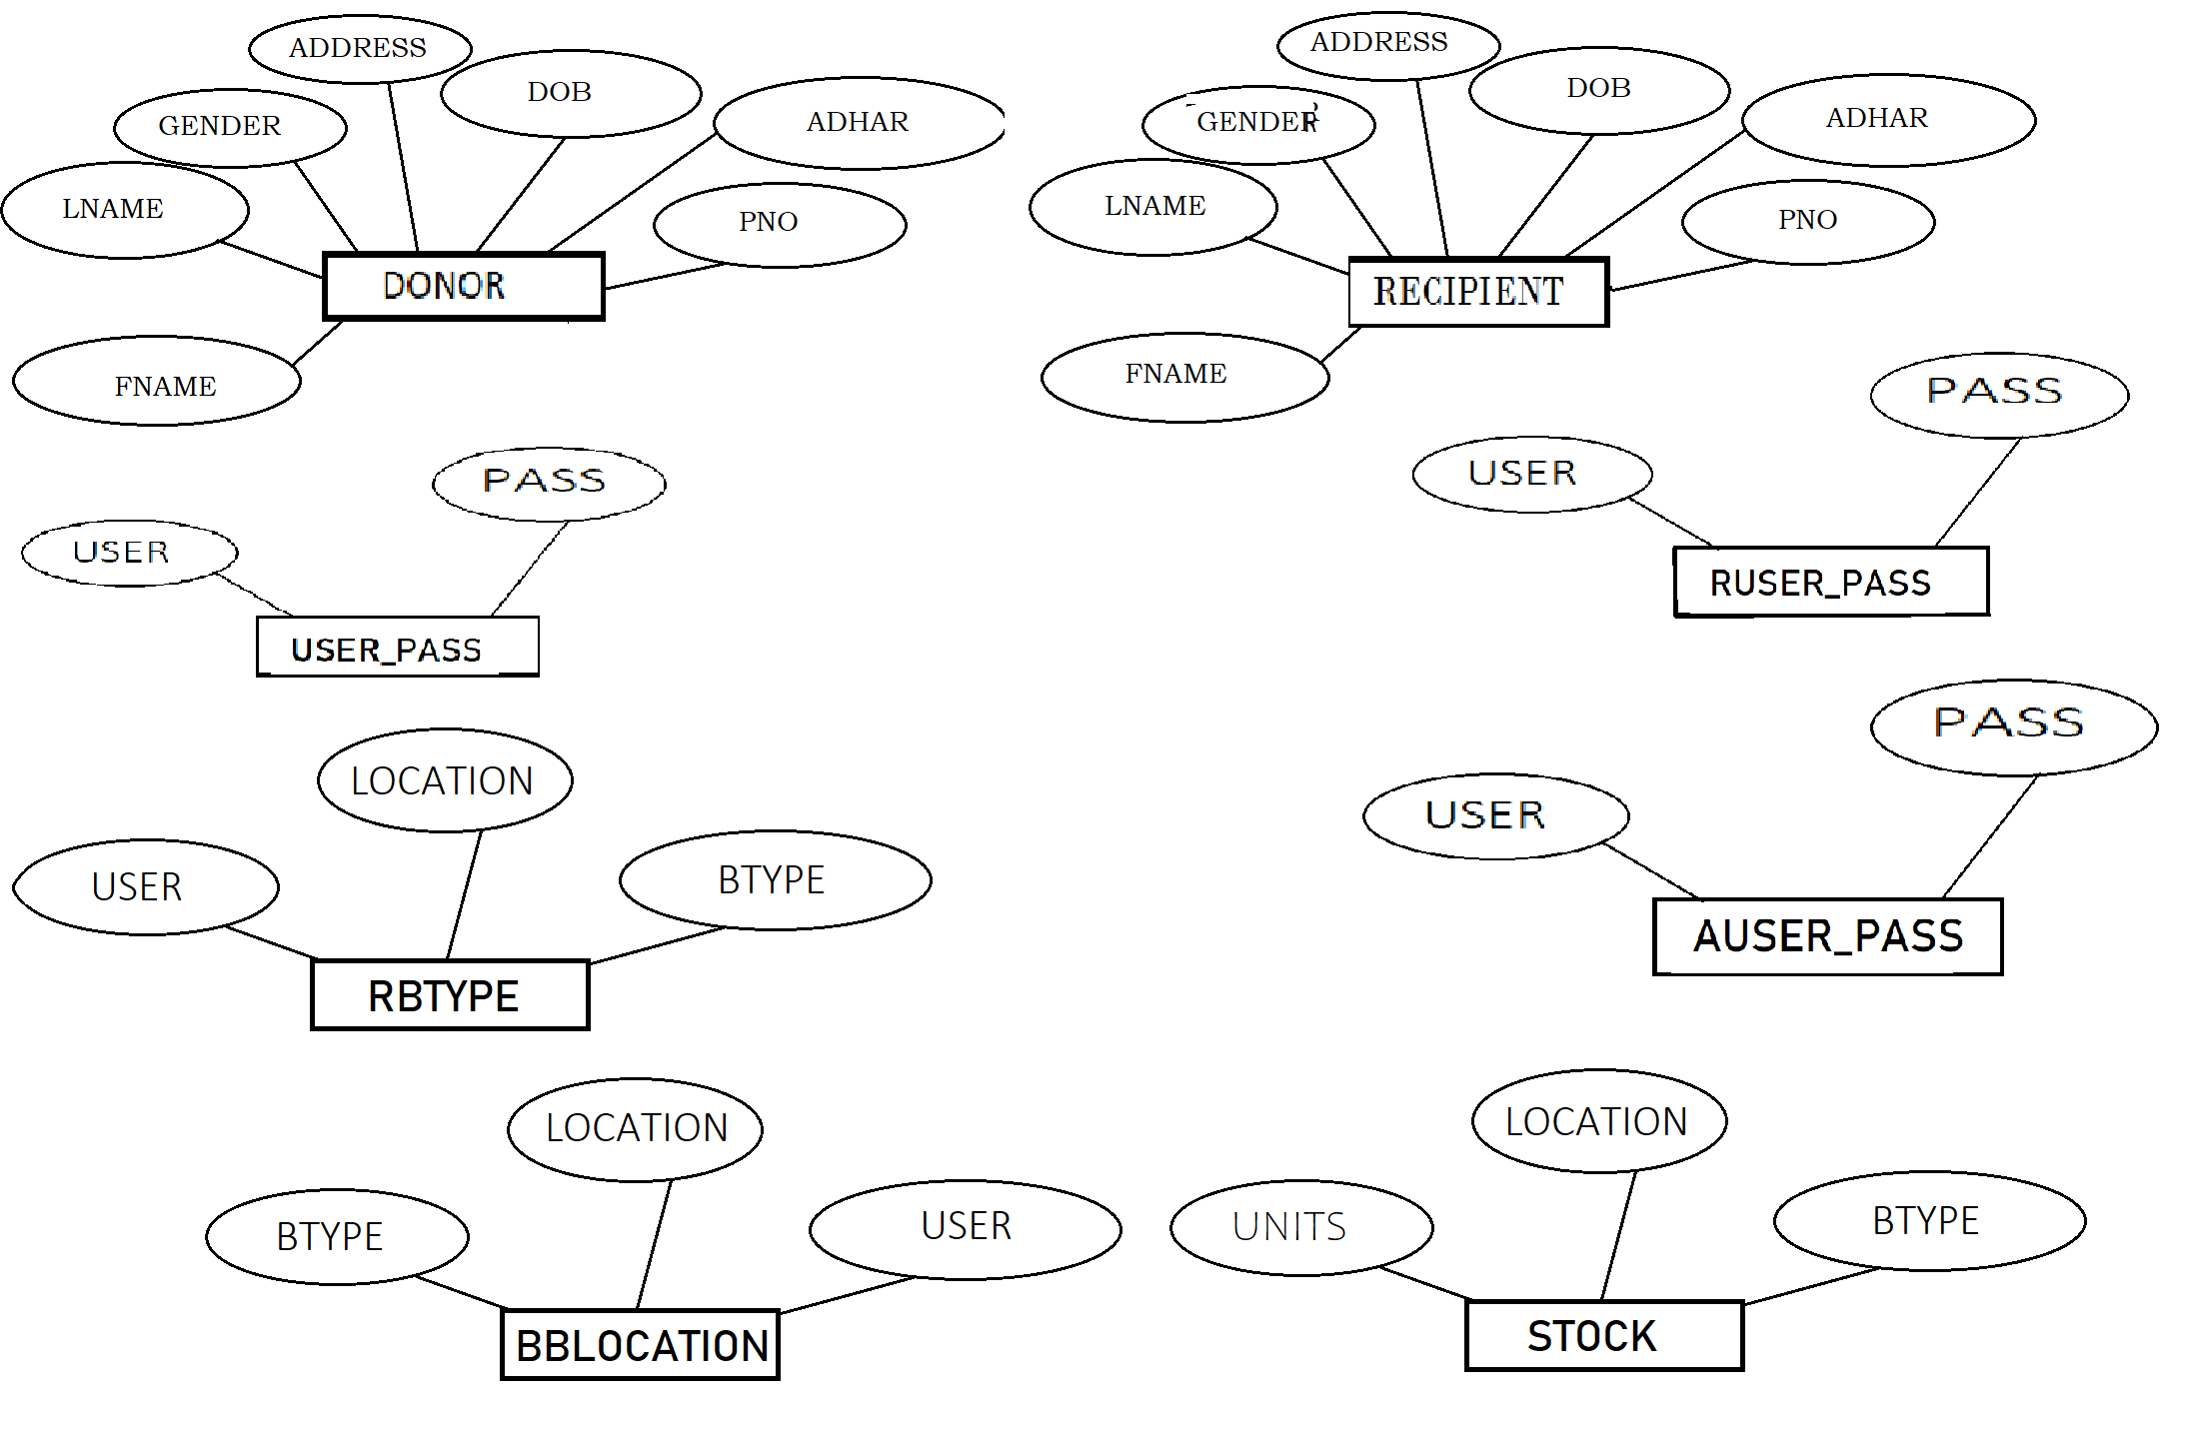

**Figure 4.1 E-R Diagram of Blood Bank Management System**

An entity–relationship model (ER model) describes inter-related things of interest in a specific domain of knowledge. An ER model is composed of entity types (which classify the things of interest) and specifies relationships that can exist between instances of those entity types.

In software engineering an ER model is commonly formed to represent things that a business needs to remember in order to perform business processes. Consequently, the ER model becomes an abstract data model that defines a data or information structure that can be implemented in a database, typically a relational database.

**4.2 Schema Diagram**

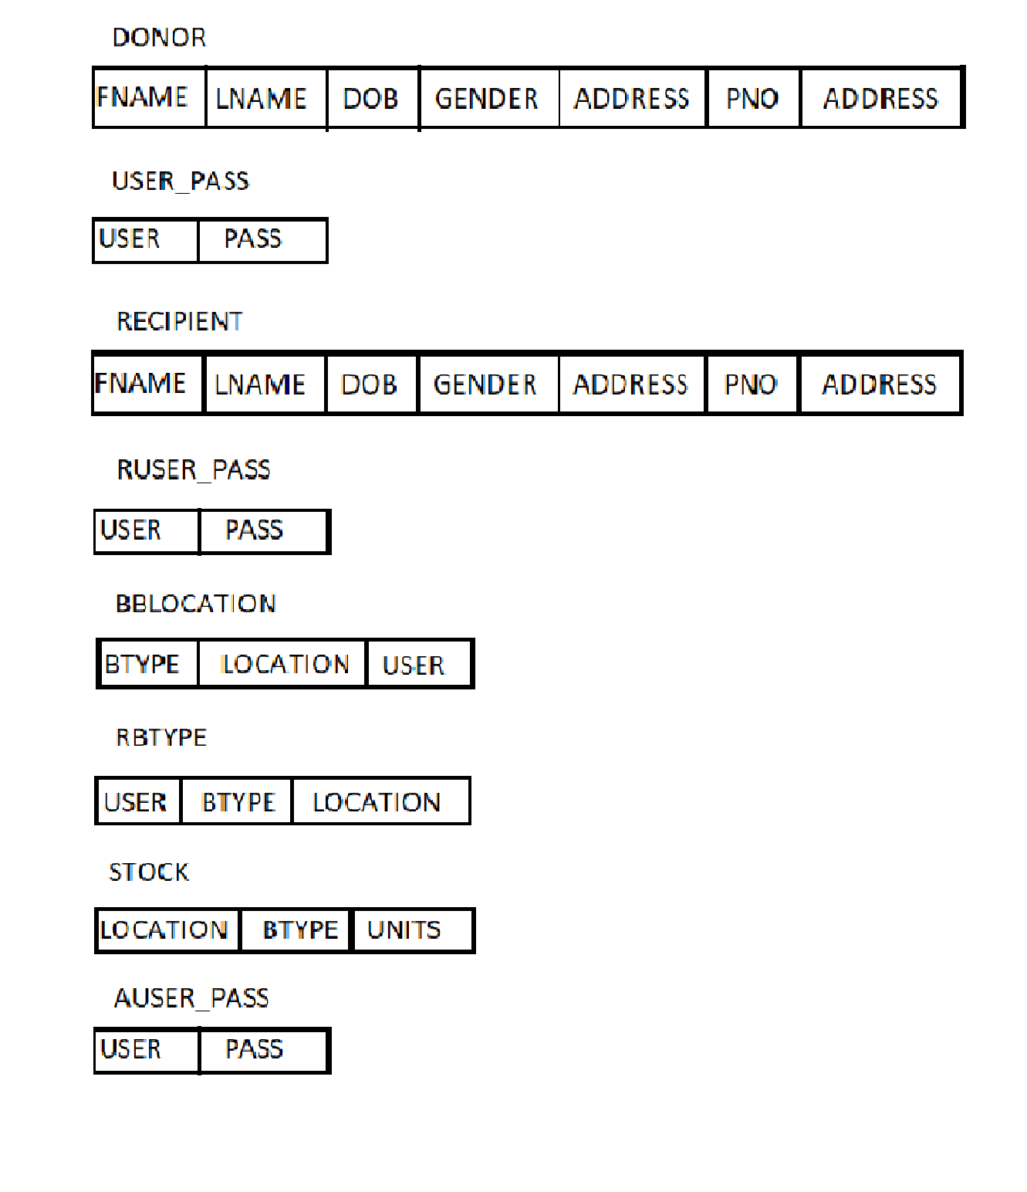The database schema of a database system is its structure described in a formal language supported by the database management system (DBMS). The term "schema" refers to the organization of data as a blueprint of how the database is constructed (divided into database tables in the case of relational databases). The formal definition of a database schema is a set of formulas (sentences) called integrity constraints imposed on a database.

**Figure 4.2 Schema Diagram of Blood Bank Management System**

**CHAPTER 5**

**SYSTEM IMPLEMENTATION**

**5.1 Modules Description**

**\*Create,** create table statement is used to create table to store data.

**Create code for every table**

**5.1.1 Donor Table**

Create table DONOR(

Fname varchar(50),

Lname varchar(30),

Dob date,

Gender varchar(10),

Address varchar(50),

Pno bigint,

Adhar bigint

);

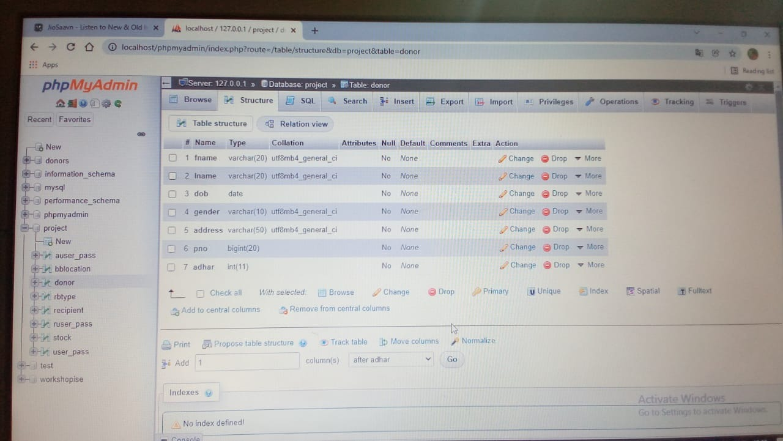

**Figure 5.1.1 Donor Table**

**5.1.2 Donor Username and Password Table**

Create table user\_pass(

User varchar(25),

Pass varchar(25)

);

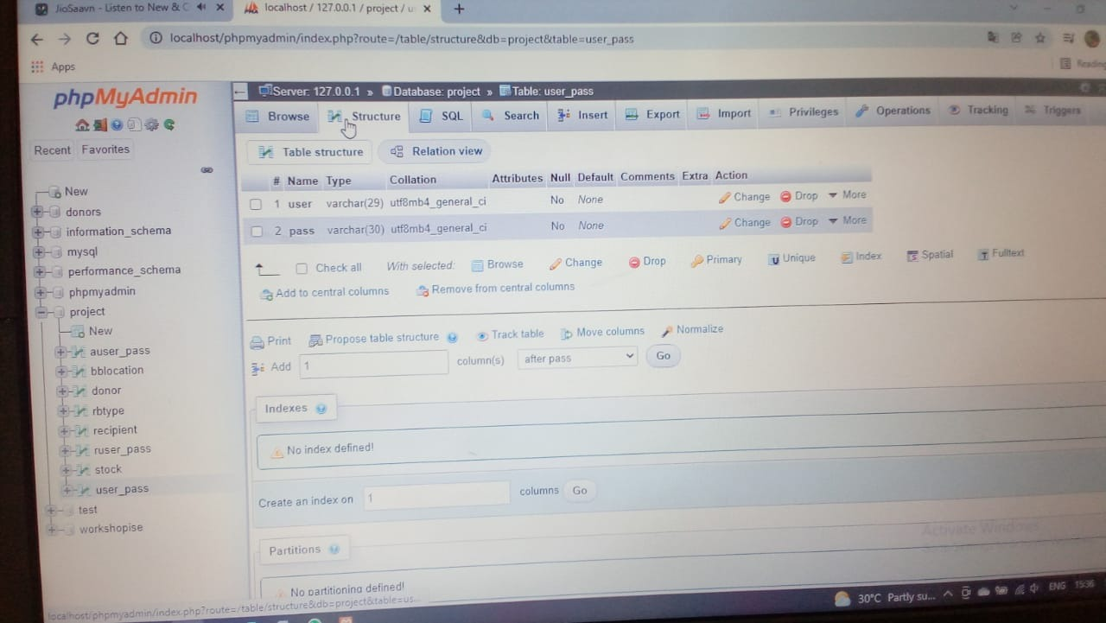

**Figure 5.1.2 Username and Password Table**

**5.1.3 Recipient Details Table**

Create table Recipient**(**

Fname varchar(50),

Lname varchar(30),

Dob date,

Gender varchar(10),

Address varchar(50),

Pno bigint,

Adhar bigint

);

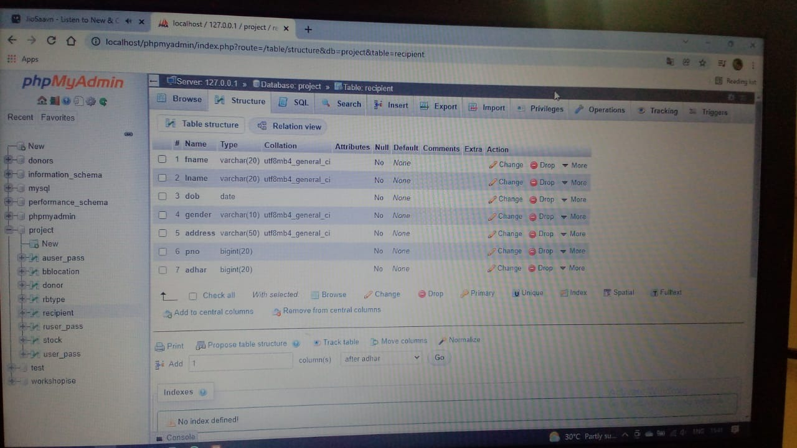

**Figure 5.1.3 Recipient Table**

**5.1.4 Recipient Username and Password Table**

Create table ruser\_pass(

User varchar(25),

Pass varchar(25)

);

**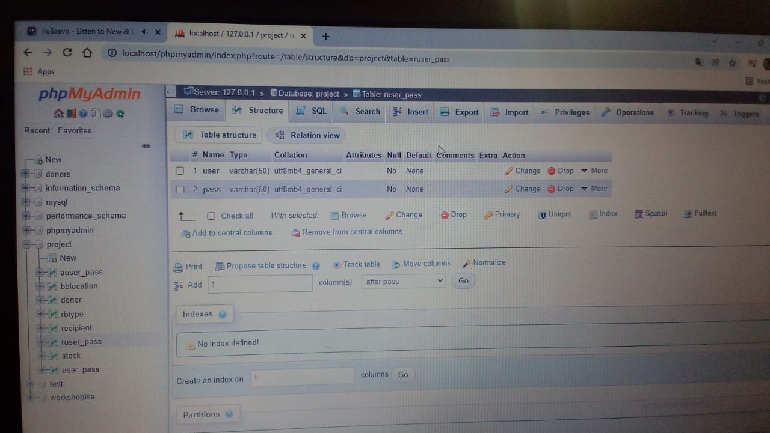**

**Figure 5.1.4 Recipient Username and Password Table**

**5.1.5 Donor - Donation of Blood Type and Location**

Create table bblocation(

Btype varchar(30),

Location varchar(50),

User varchar(30)

**);**

**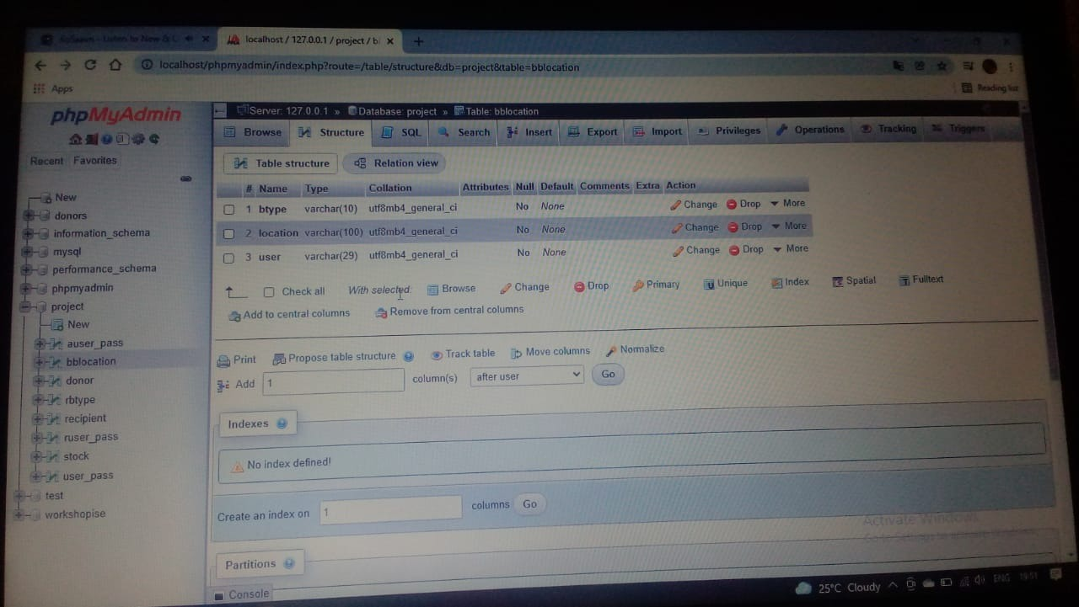**

**Figure 5.1.5 Donor Blood Donation Location Table**

**5.1.6 Recipient Requesting Blood Type and Location Table**

Create table rbtype(

User varchar(30),

Btype varchar(20),

Location varchar(50)

);

**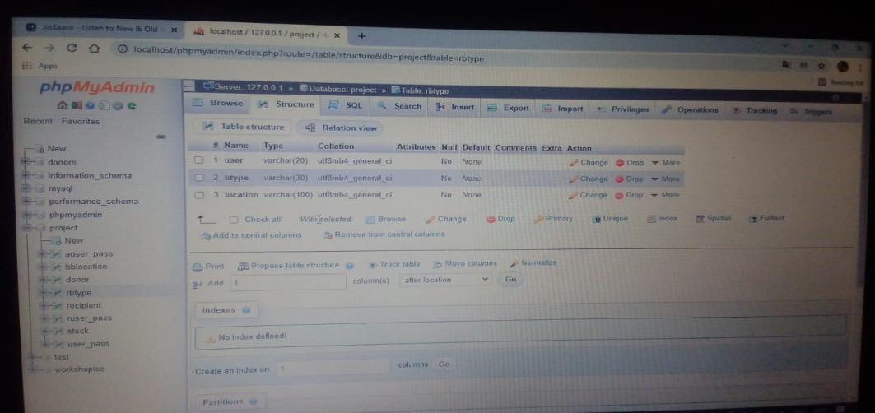**

**Figure 5.1.6 Recipient Requesting Blood Type and Blood Bank Location Table**

**5.1.7 Admin Login Username and Password**

Create table auser\_pass(

User varchar(30),

Pass varchar(30)

);

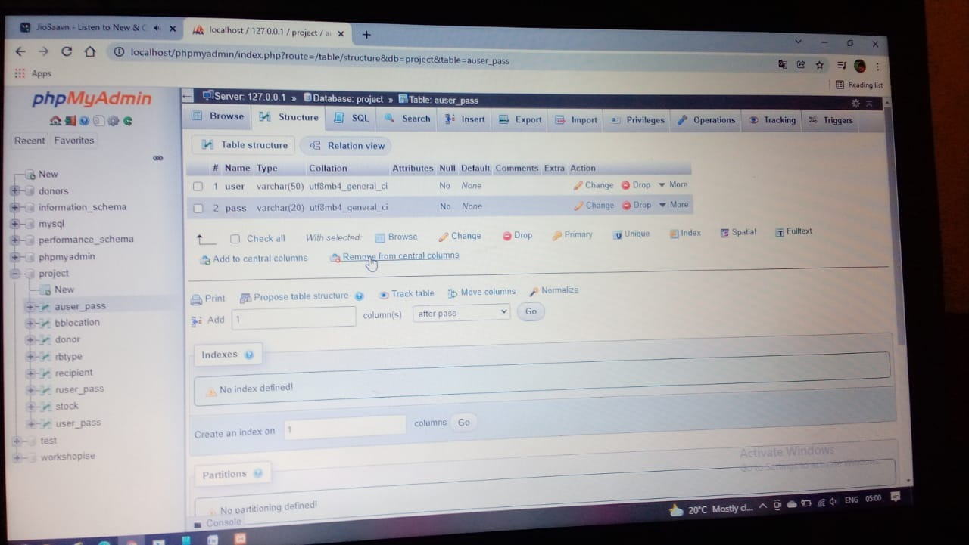

**Figure 5.1.7 Admin Login Username and Password Table**

**5.1.8 Stock Table-Details of Blood, Blood Bank and Location where Blood is available**

Create Table Stock(

Location varchar(50),

Btype varchar(10),

Units int

);

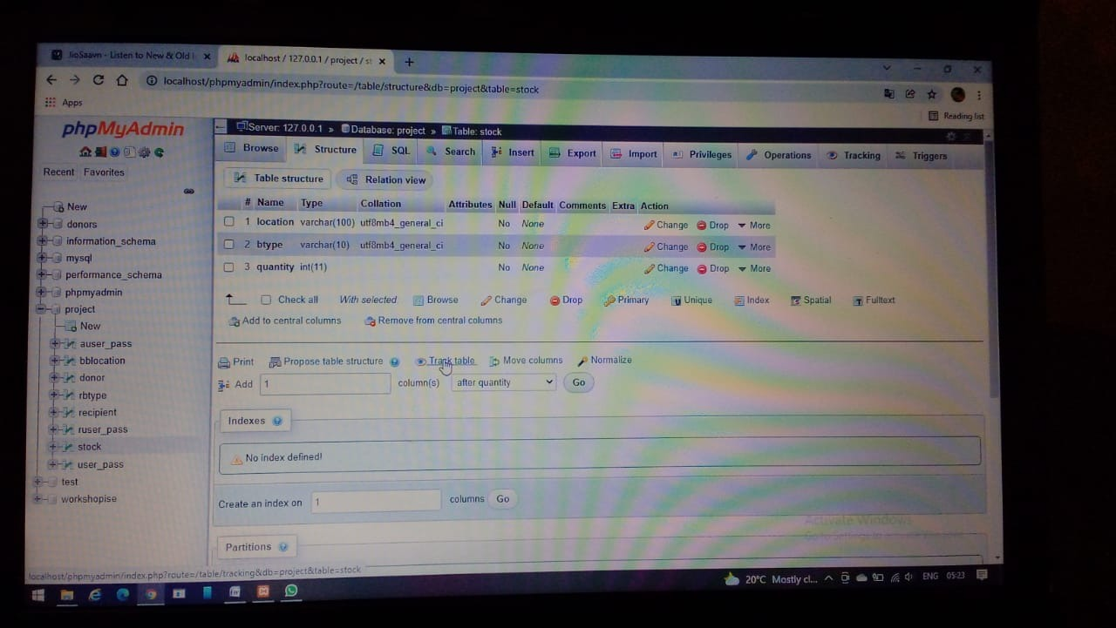

**Figure 5.1.8 Stock Table**

**5.2 OPERATIONS PERFORMED:**

**\*Insertion,** insertion is use to insert the tuple or row to the table. We insert value from frontend by making use HTTP the value inserted from to frontend will be going to store in backend database in XAMPP Server

**\*Update,** update will help to edit the tables in the database. In this project we have given update option for table package, to update the place column in package table.

**\*Delete,** delete will help us to delete a tuple or row from the table. In this project we have delete option for table employee to delete the particular row or employee information from the table.

**\*Stored procedure,** a stored procedure is a set of Structure Query Language(SQL) statements with an assigned name, which are stored in a relational database management system as a group, so it can be reused and shared by multiple programs. Stored procedure can access or modify data

**CHAPTER 6**

**SAMPLE OUTPUT**

**6.1 Screenshots**

**6.1.1** **Welcome Page**

**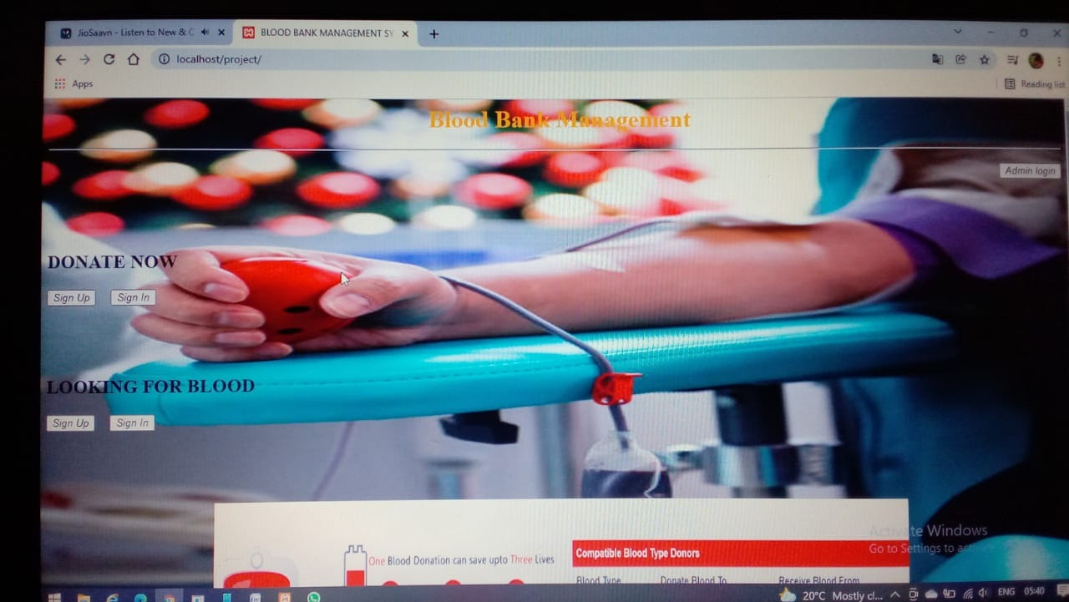**

**Figure 6.1.1 Welcome Page**

**6.1.2 Donor Details**

**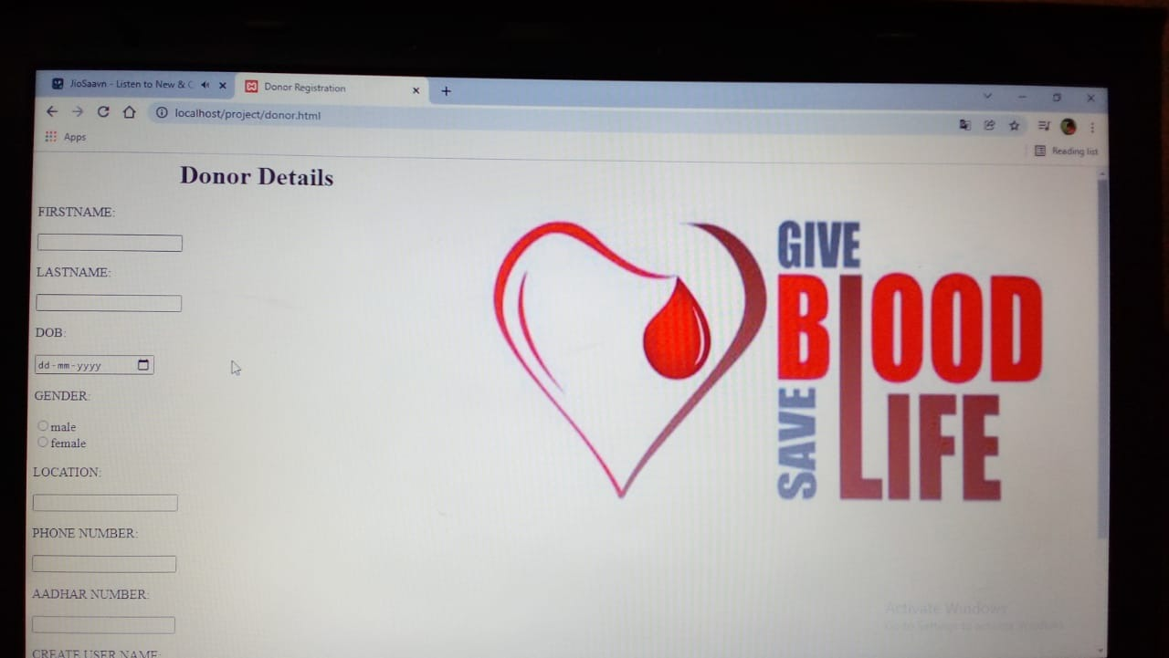**

**Figure 6.1.2 Donor Details**

**6.1.3 Recipient Details**

**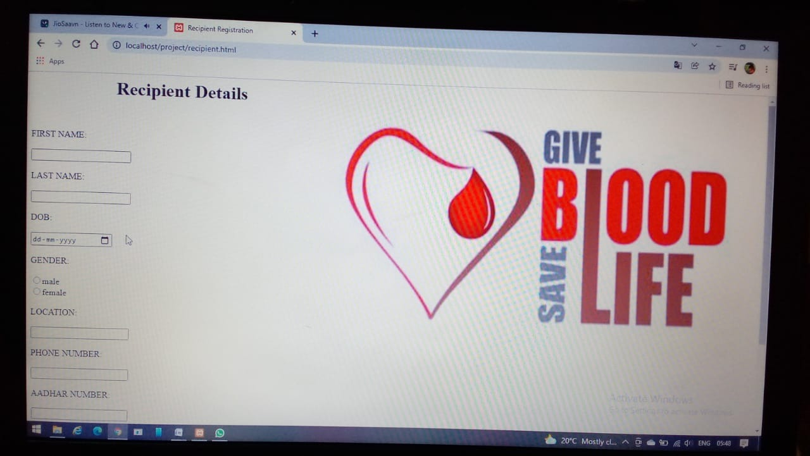**

**Figure 6.1.3 Recipient Details**

**6.1.4 Admin Login Page**

**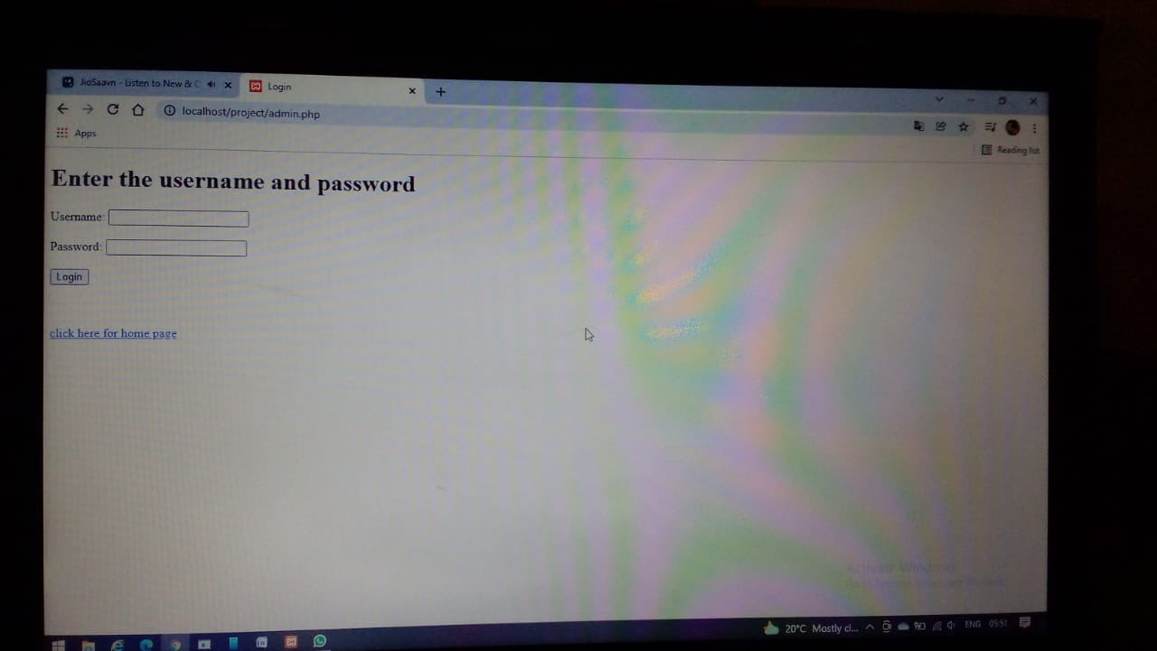**

**Figure 6.1.4 Admin Login Page**

**6.1.5 STORED PROCEDURE**

**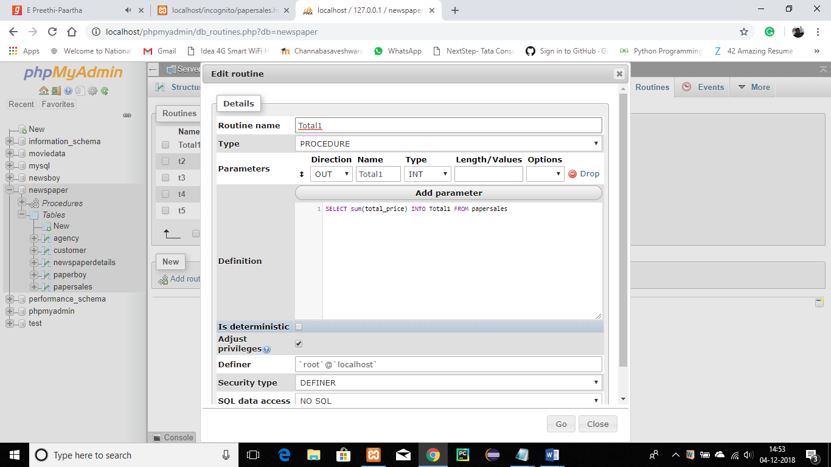**

**Figure 6.1.5 Stored Procedure**

**Chapter 7**

**CONCLUSION**

It has been a great pleasure for me to work on this exciting and challenging project. This project proved good for me as it provided practical knowledge of not only programming in HTML and PHP web based application and no some extent Windows Application and SQL Server, but also about all handling procedure related with **“Blood Bequeath Federal”.** It also provides knowledge about the latest technology used in developing web site and client server technology that will be great demand in future. This will provide better opportunities and guidance in future in developing projects independently.

**Future work:**

1. Implementation of algorithm for Online Validation

2. Uses feedback-based evolution of data base

**BIBLIOGRAPHY**

[1] [www.w3schools.com](http://www.w3schools.com)

[2] [www.php.net](http://www.php.net)

[3] [www.YouTube.com](http://www.YouTube.com)

[4] [www.quora.com](http://www.quora.com)

[5] [www.Wikipedia.org](http://www.Wikipedia.org)

[6] Ramez Elmasri and Shamkant B. Navathe, 7th edition, 2017, Pearson